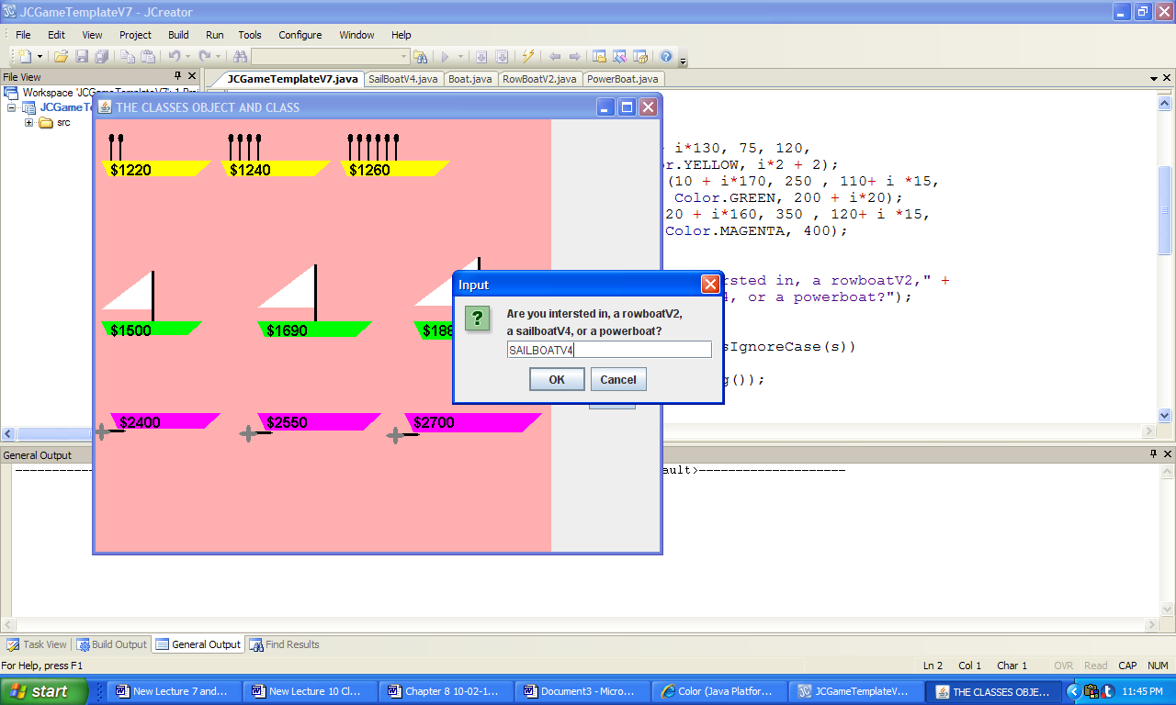 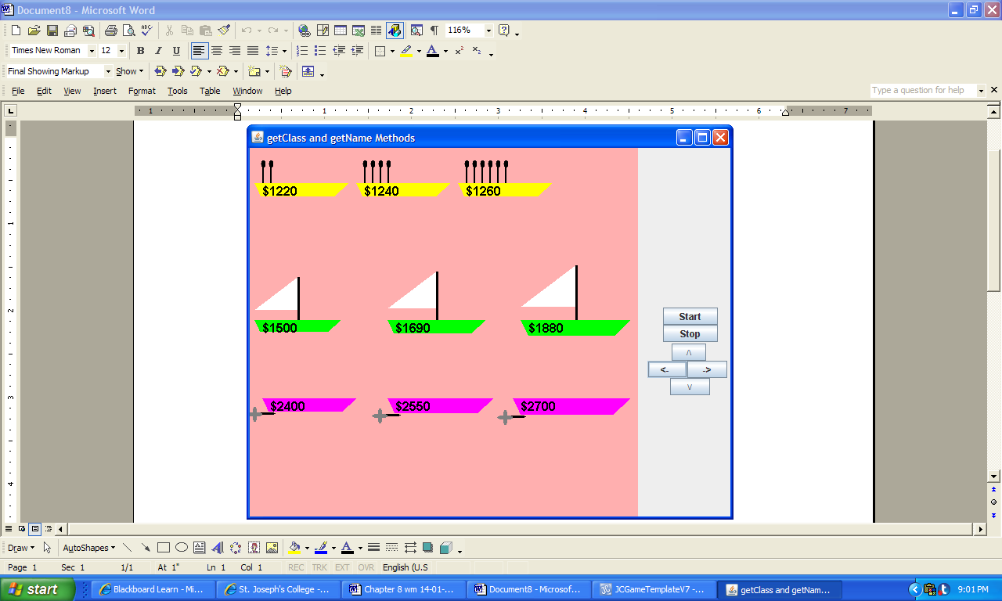

**a) b)**

***System Console Output:***

Location: (10, 250), length: 110, Color: java.awt.Color[r=0,g=255,b=0], Sail Area: 200

Location: (180, 250), length: 125, Color: java.awt.Color[r=0,g=255,b=0], Sail Area: 220

Location: (350, 250), length: 140, Color: java.awt.Color[r=0,g=255,b=0], Sail Area: 240

**Figure 8.35 The output Produced by the application ObjectAndClass.**